GIT : <https://github.com/CarlCool/eMartCase>

SQL PART is in folder SQL

SpringBoot and Test PART is in folder eMartSpringBoot

Below cases is for test in post man:

Get : localhost:8081/user/buyer/1

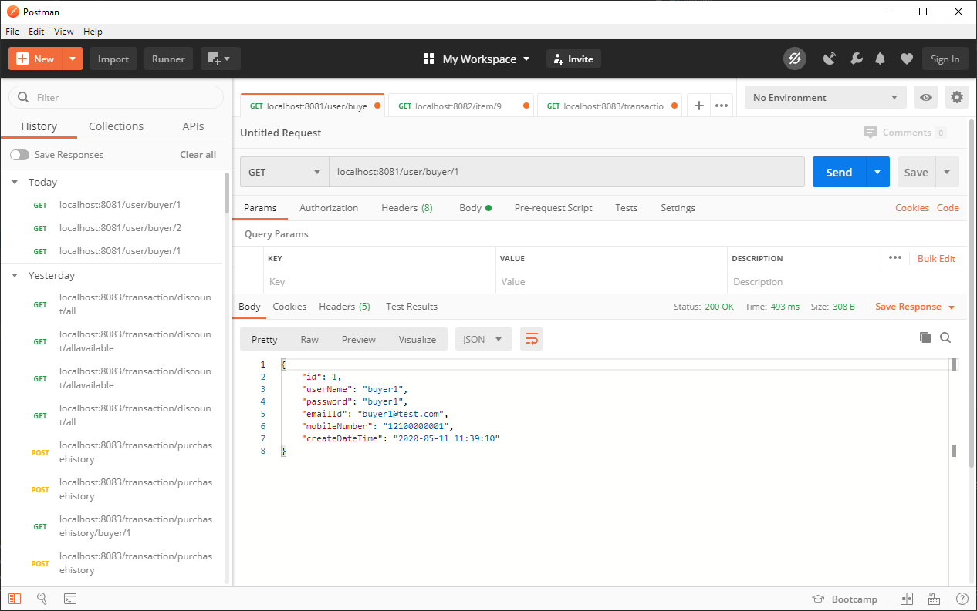

Get : localhost:8081/user/buyer/email/buyer2@test.com

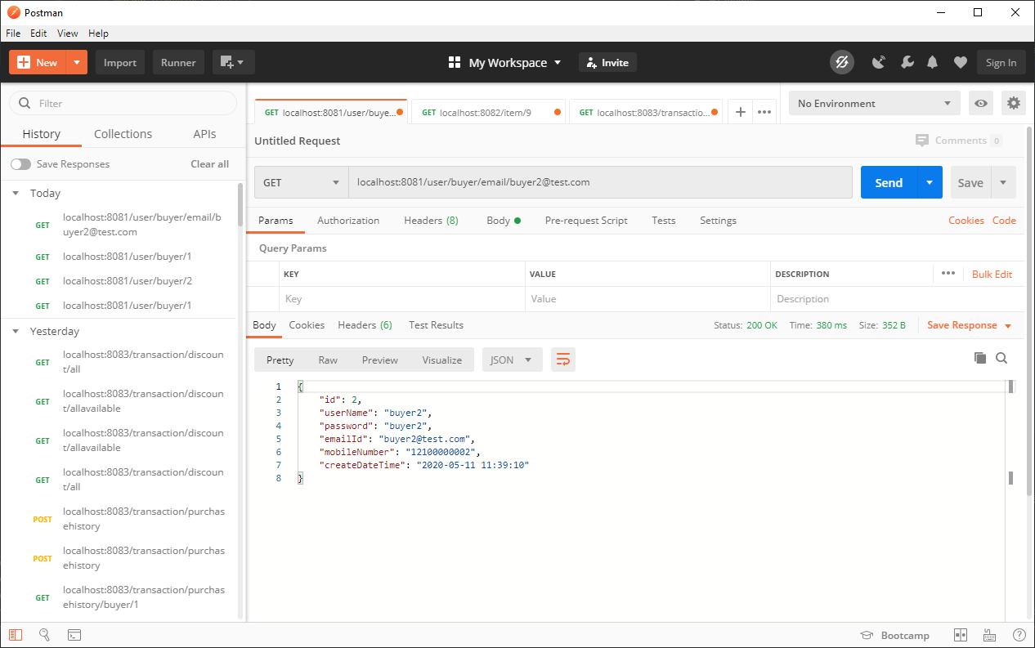

POST : localhost:8081/user/buyer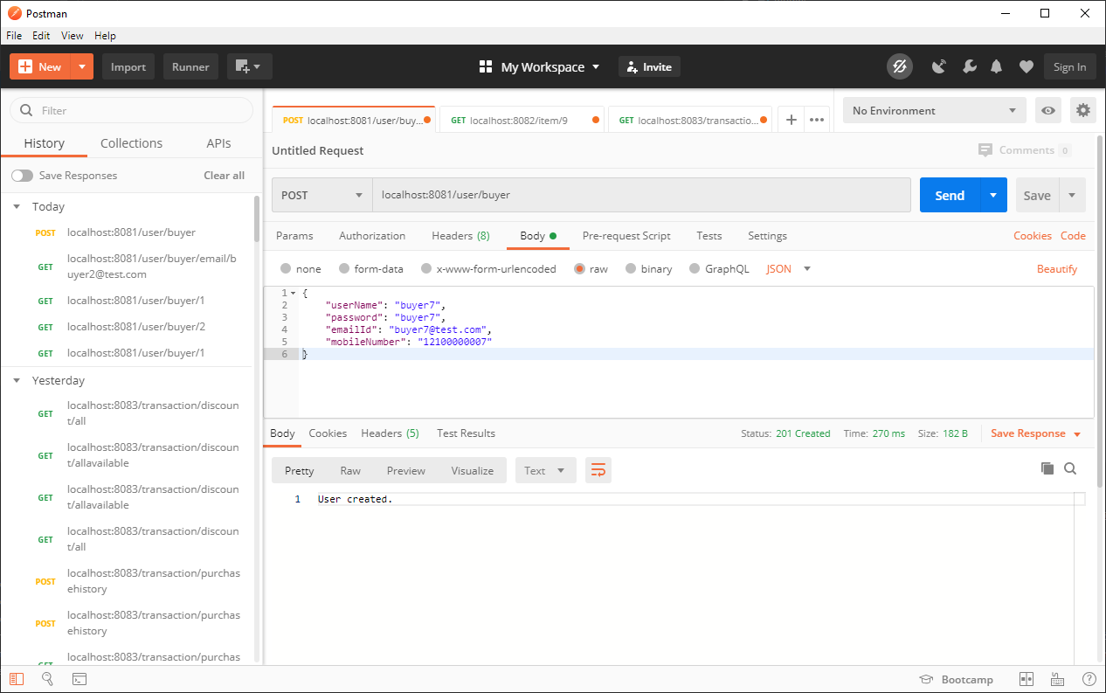

GET : localhost:8081/user/seller/1

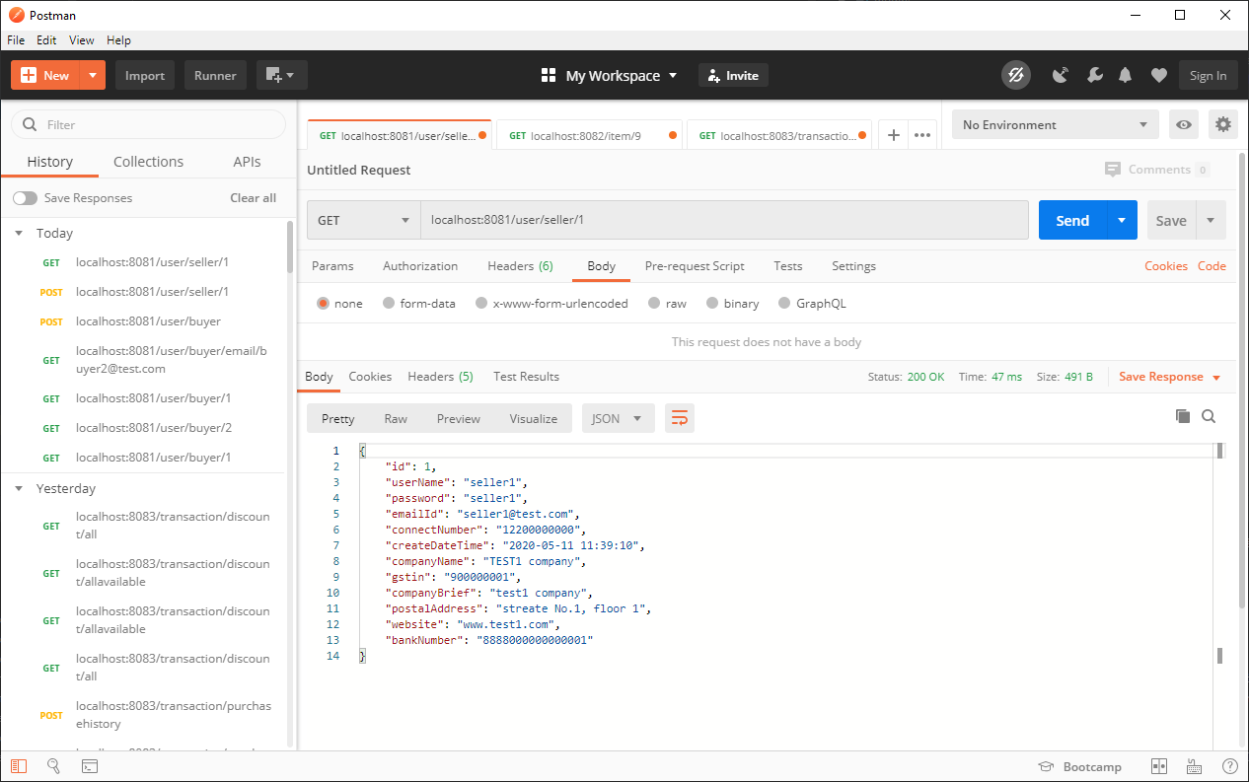

GET : localhost:8081/user/seller/email/seller3@test.com

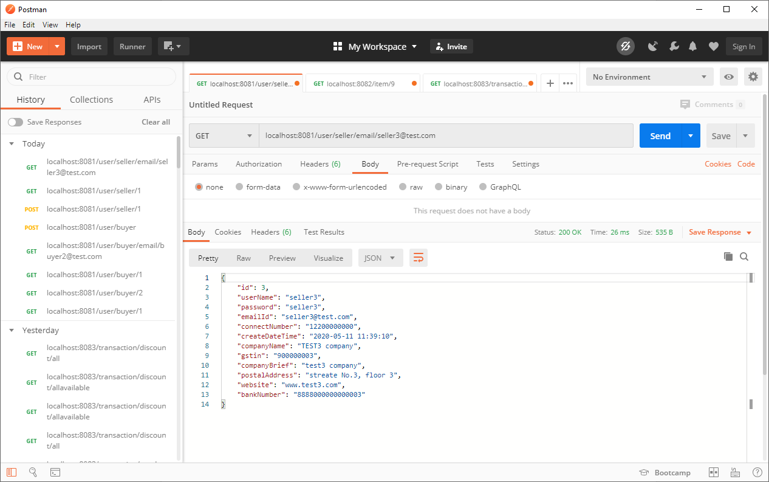

POST: localhost:8081/user/seller

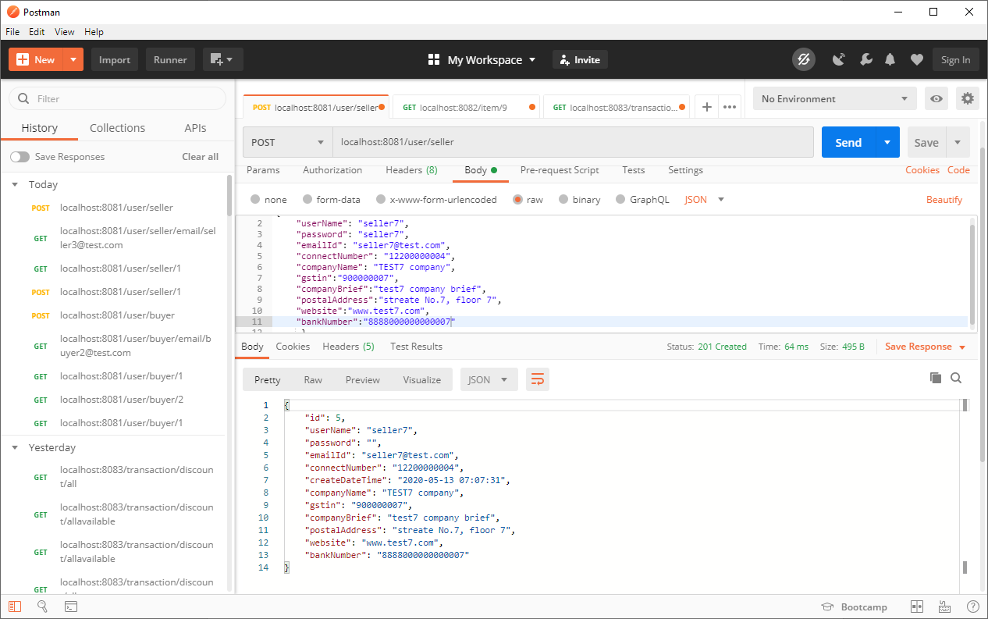

GET : localhost:8082/item/details

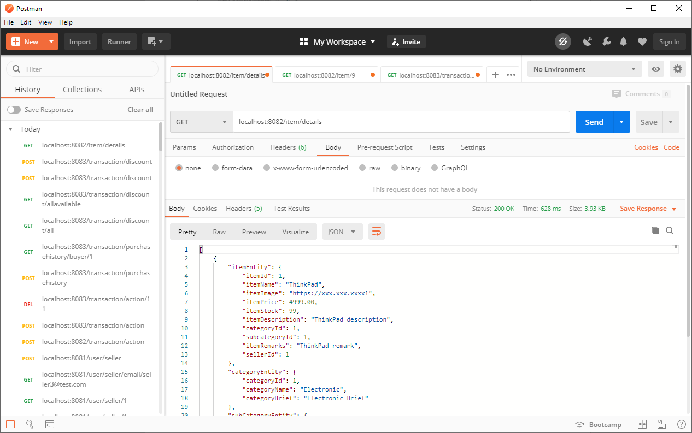

GET : localhost:8082/item/1

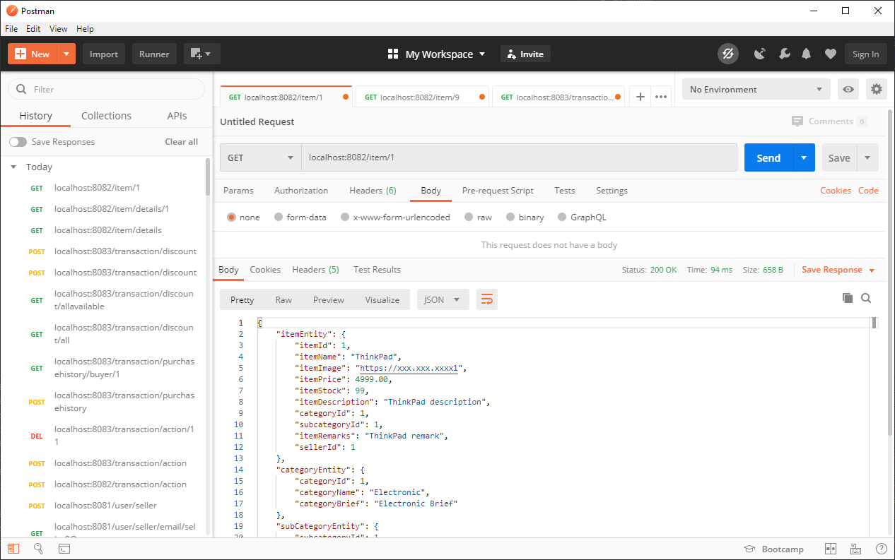

POST : localhost:8082/item/details

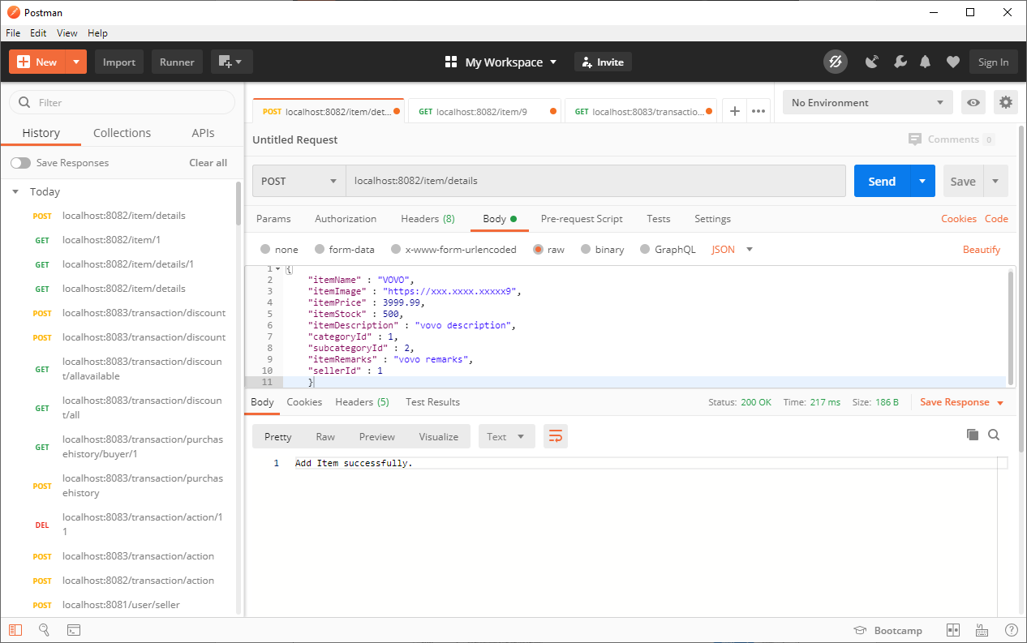

PUT : localhost:8082/item/details

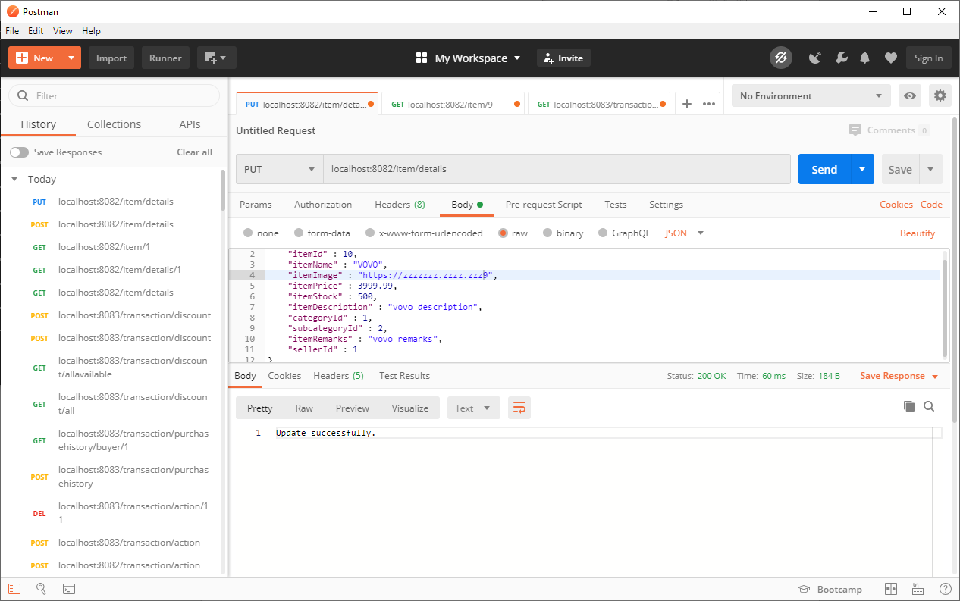

DELETE : localhost:8082/item/10

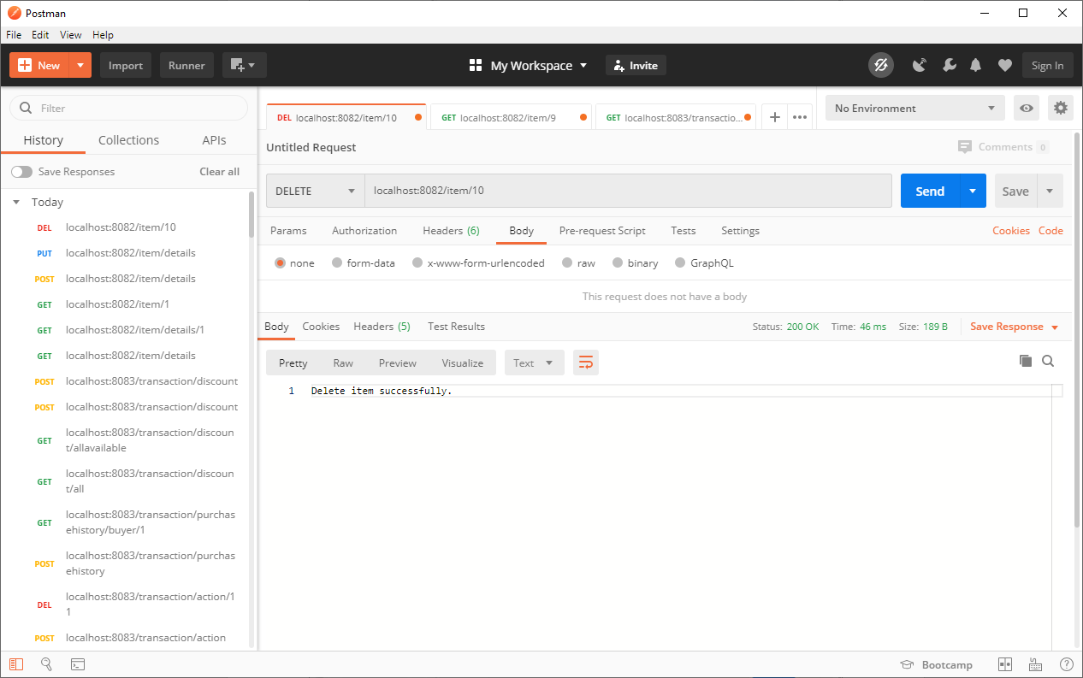

GET : localhost:8082/item/category/all

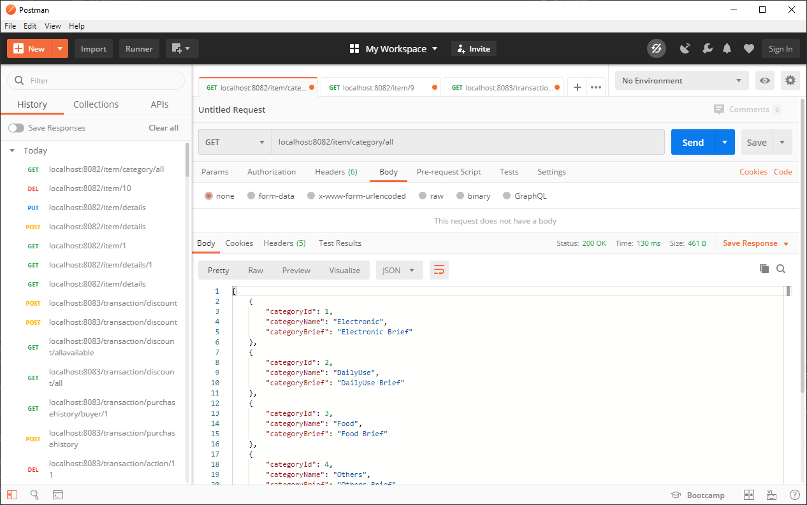

GET localhost:8082/item/category/allname

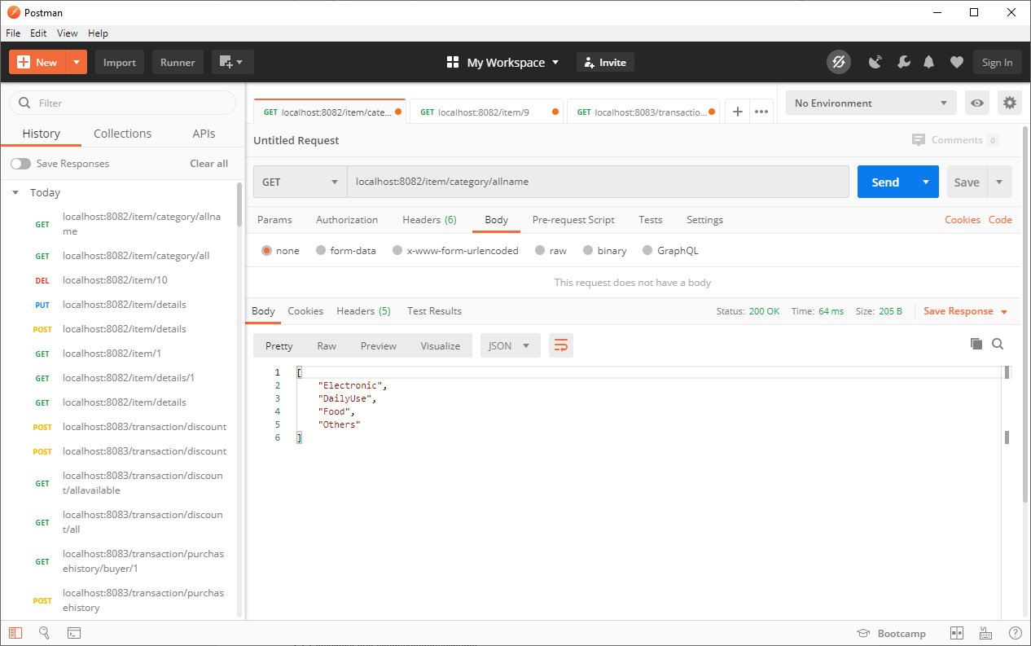

GET : localhost:8082/item/category/2

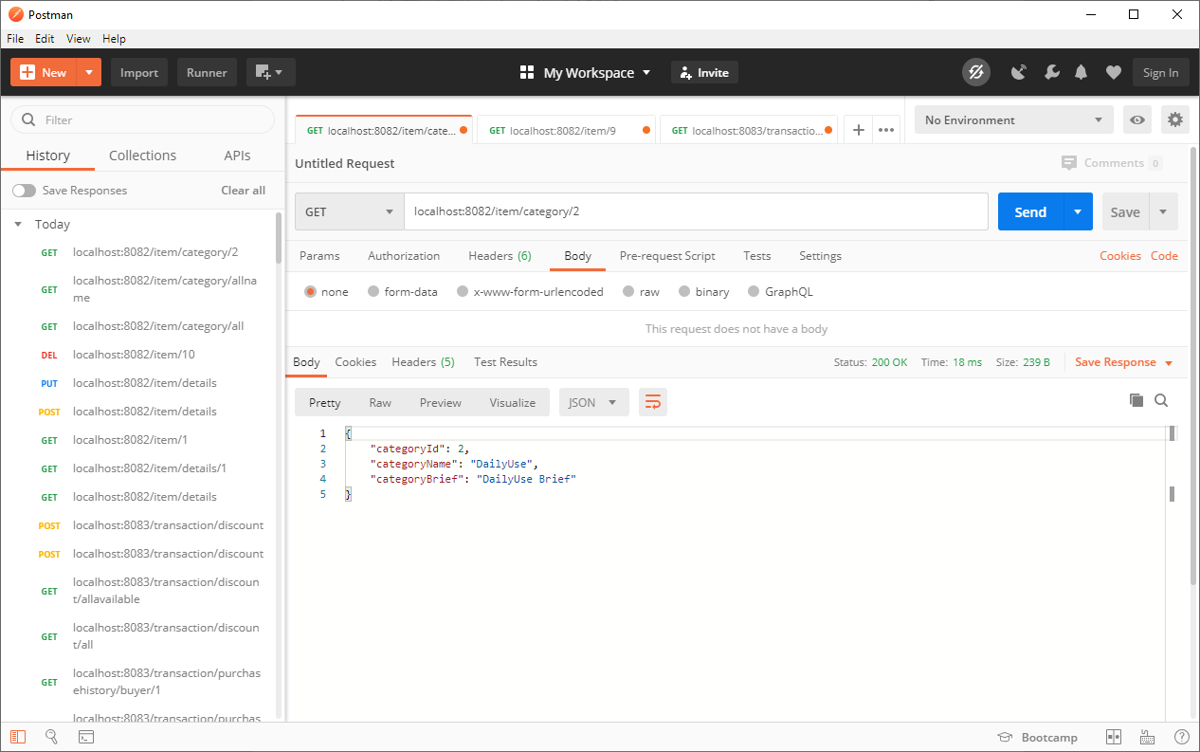

localhost:8082/item/subcategory/all

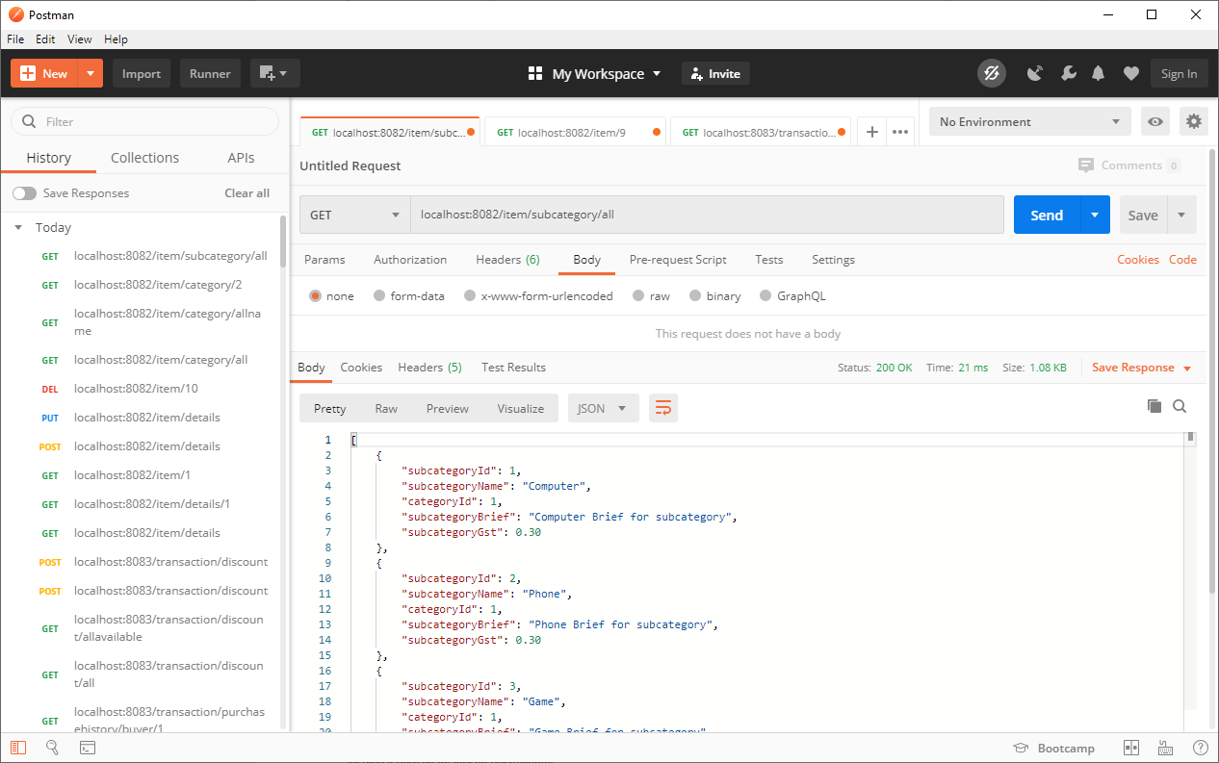

localhost:8082/item/subcategory/allname

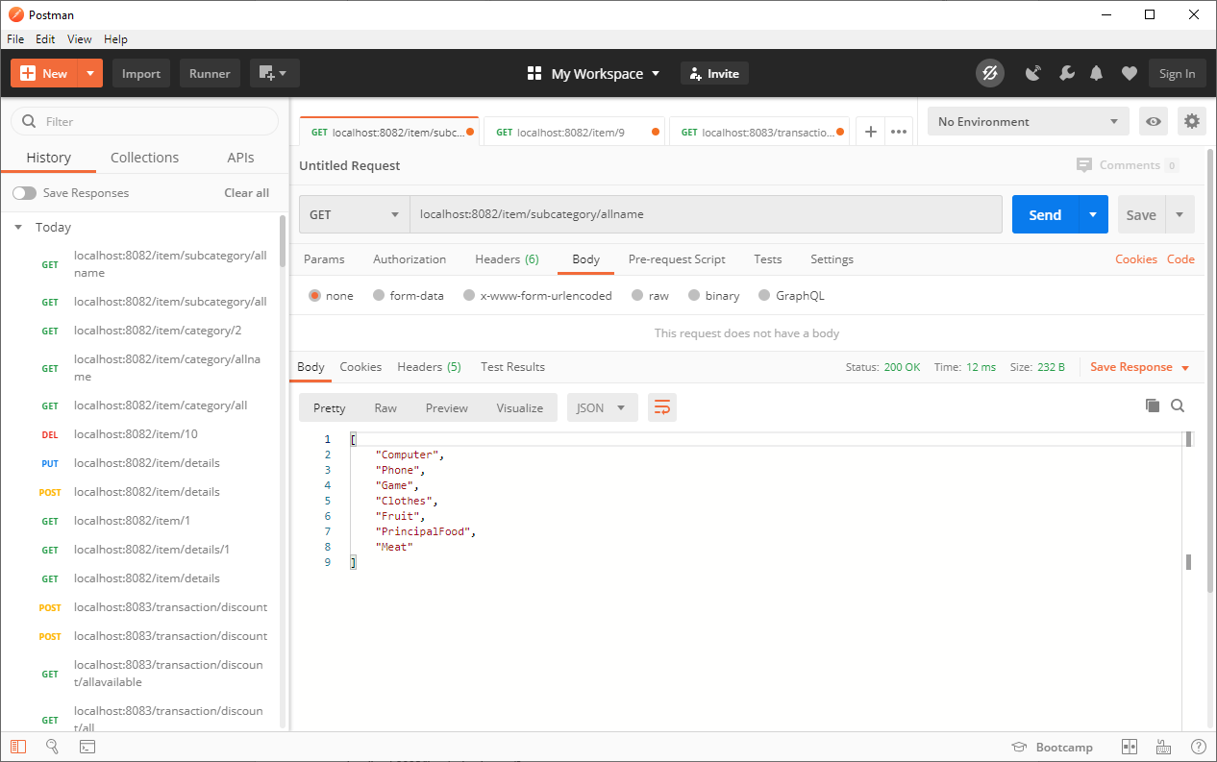

localhost:8082/item/subcategory/3

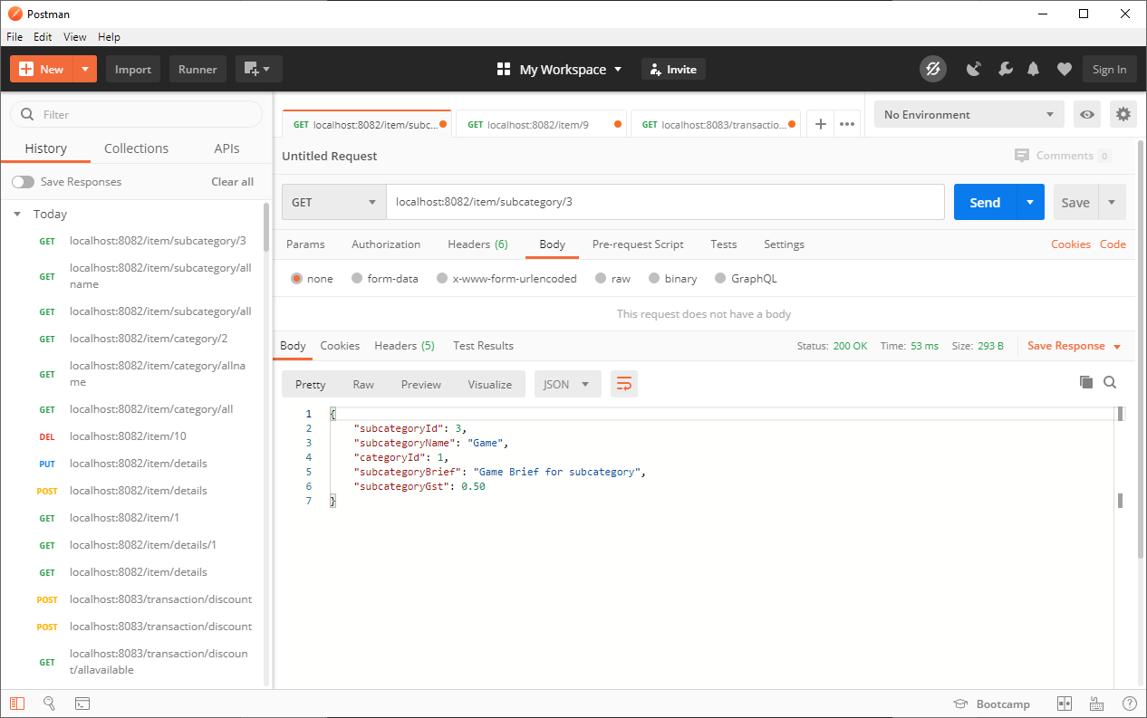

GET : localhost:8082/item/cart/1

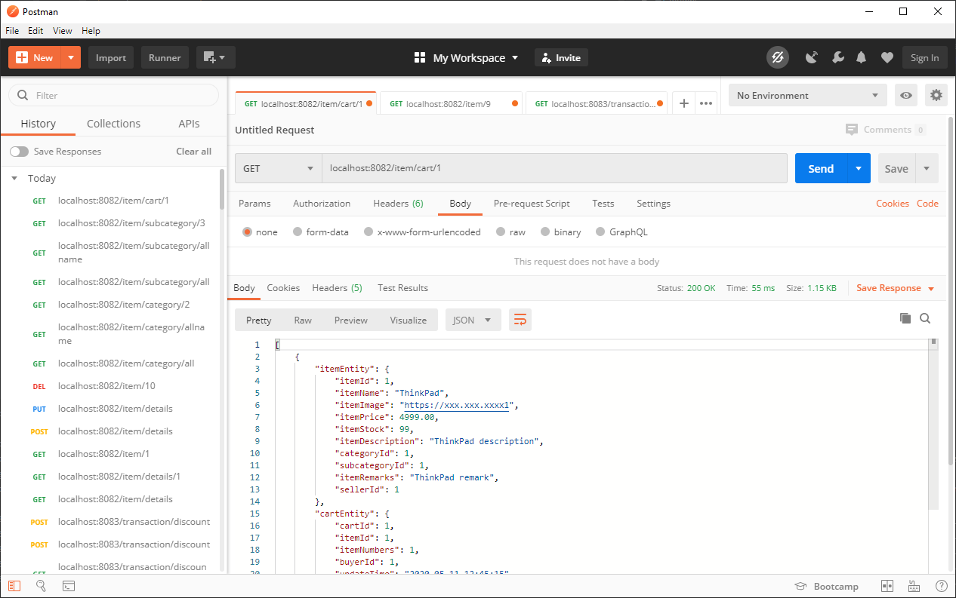

POST : localhost:8082/item/cart

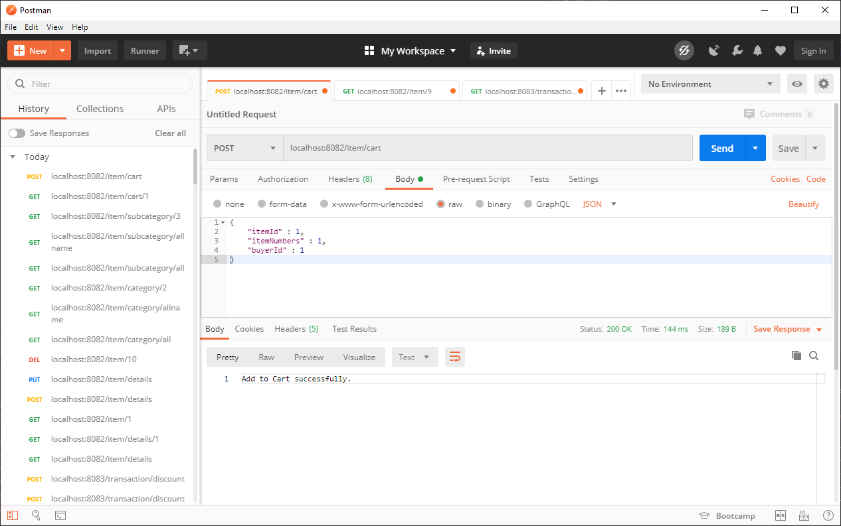

PUT : localhost:8082/item/cart

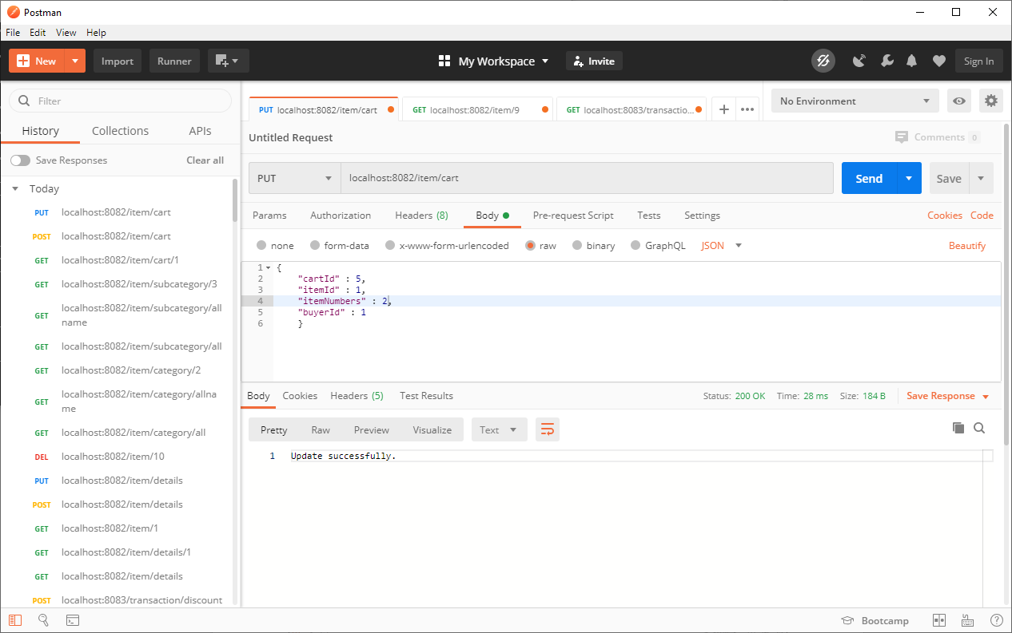

POST: localhost:8083/transaction/action

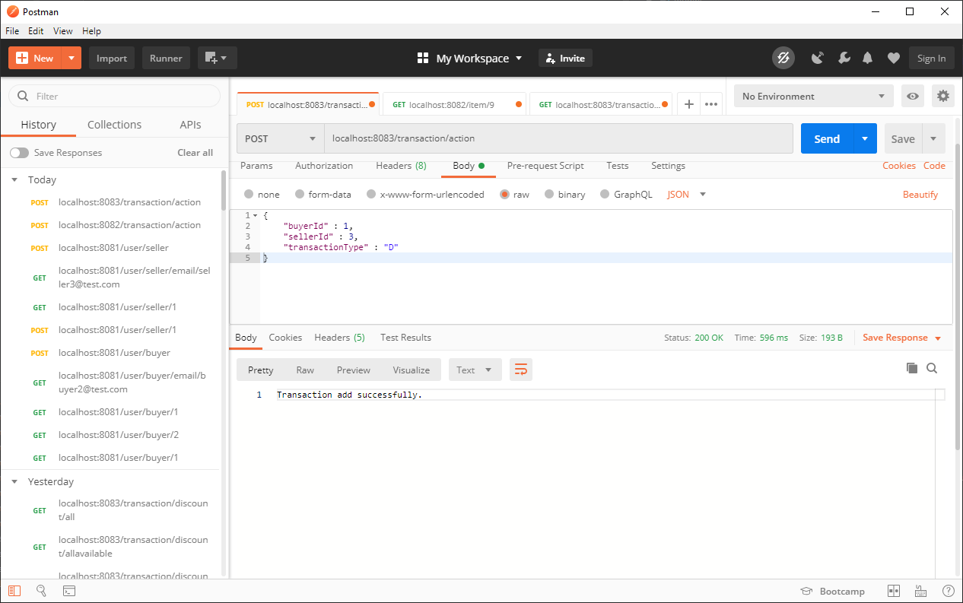

DELETE : localhost:8083/transaction/action/11

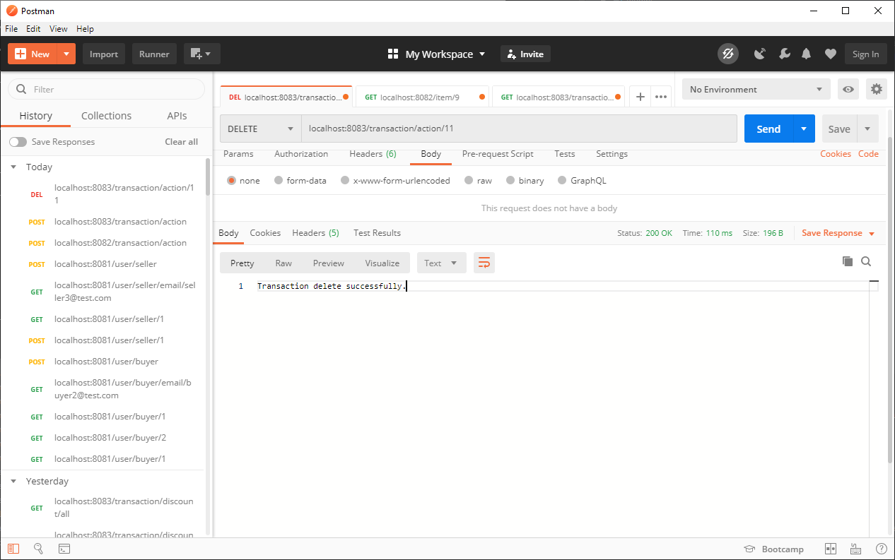

POST : localhost:8083/transaction/purchasehistory

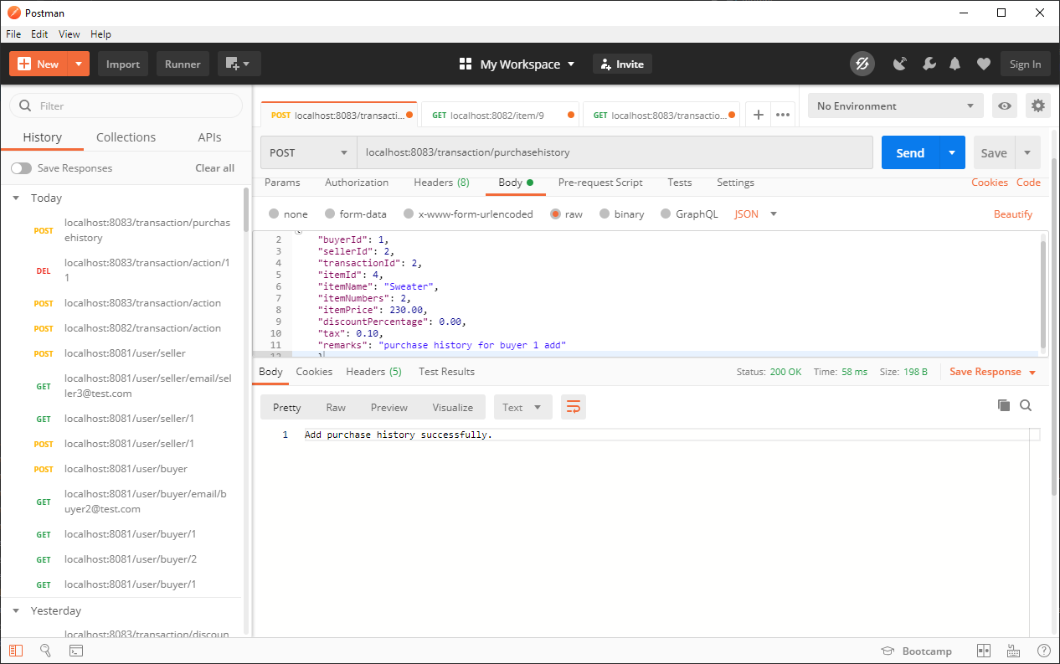

GET : localhost:8083/transaction/purchasehistory/BUYER/1

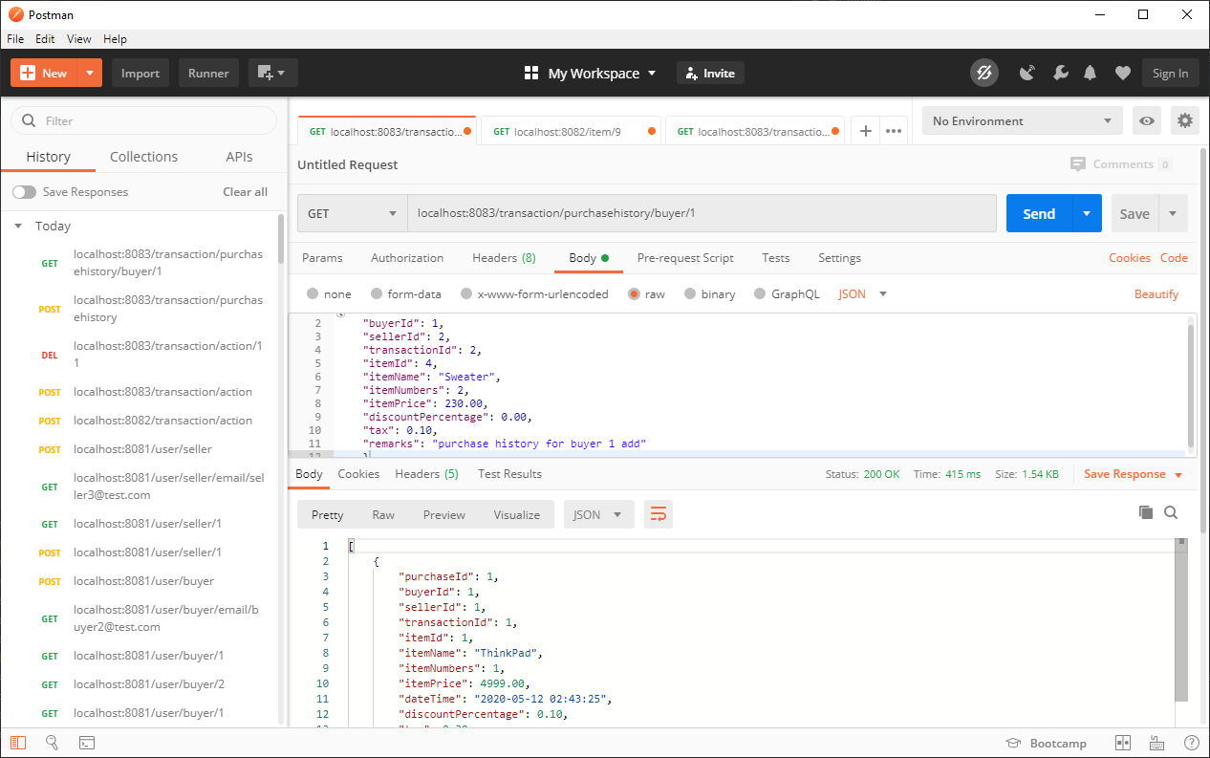

GET : localhost:8083/transaction/discount/all

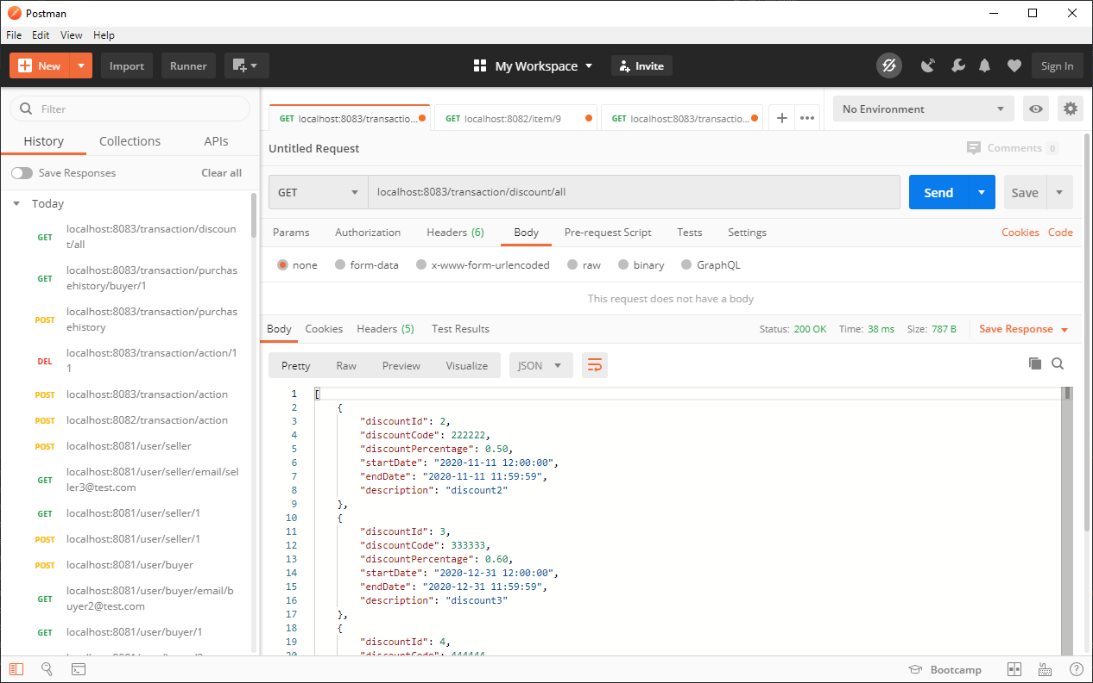

GET : localhost:8083/transaction/discount/allavailable

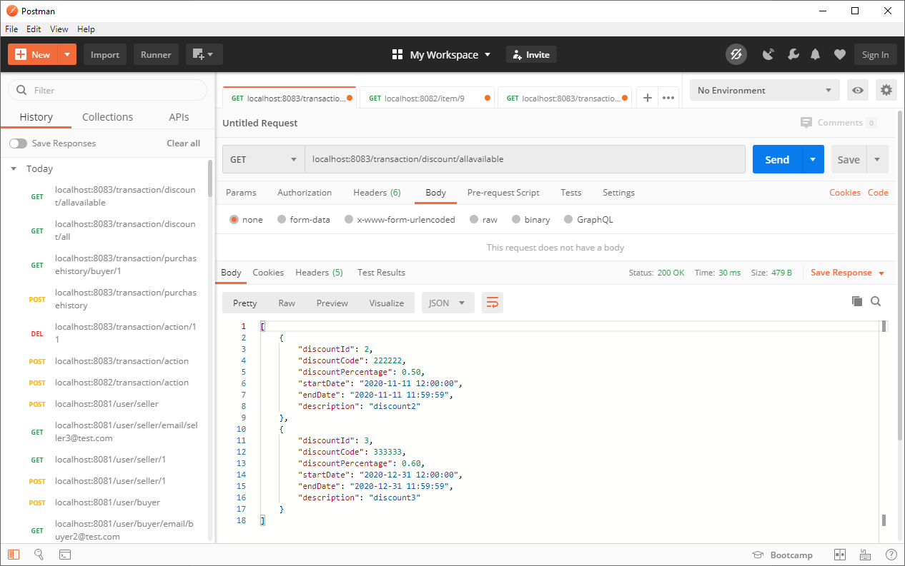

POST : localhost:8083/transaction/discount

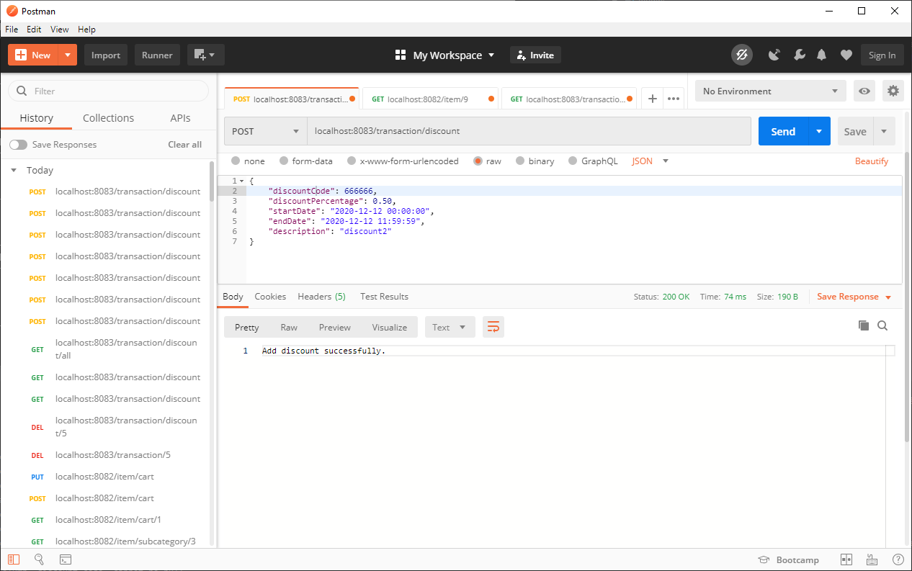

DELETE : localhost:8083/transaction/discount/5 